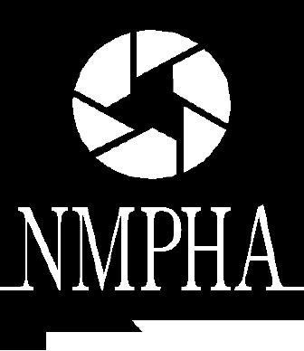

NEW MEXICO PUBLIC HEALTH ASSOCIATION

“Daring to Dream in Challenging Times:

A Vision of Health Equity in New Mexico”

14th Annual Health Policy Legislative Forum

Friday, December 8, 2017

Hilton Santa Fe Historic Plaza Hotel

100 Sandoval Street, Santa Fe

Please complete the form below and return by e-mail to abuko.estrada@gmail.com with “NMPHA Health Policy Legislative Forum Scholarship” in subject line. Requests will be accepted by email until Friday, November 17th. Applicants will be notified of approval via email no later than Wednesday, November 22nd. Please note that the number of scholarships given is dependent on the sufficiency of sponsorships for the Health Policy Legislative Forum.

For more information or questions, contact:
Abuko D. Estrada at: abuko.estrada@gmail.com or
Gwendolyn Gallagher at: Gwendolyn.Gallagher@state.nm.us

- Name:

- Are you requesting a scholarship to attend as:

- A student
  - School:

- Representative of an organization
  - Organization and position:

- Interested community member

- Email:

- Brief statement about why scholarship is needed (4-5 sentences)

