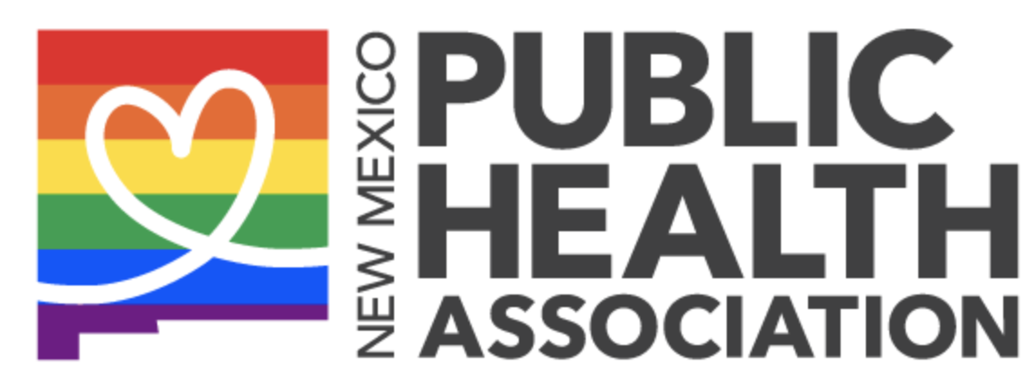

NMPHA dismayed over Texas abortion ban, court refusal to act
Date: Sep 03 2021
FOR IMMEDIATE RELEASE
Contact: Stephany Strahle, Policy Co-Chair, 505-480-9424

The New Mexico Public Health Association expresses our fears and concerns for our neighbor state as SB8, a harrowingly strict abortion ban, goes into effect in Texas. SB8 differs from other notorious six-week abortion bans in several alarming ways. Unlike previous bans introduced in recents years, legal action can be taken by any citizen regardless of their affiliation to the situation against any person seeking or planning to seek abortion services, their providers, and even their third-party transportation. If successful, plaintiffs can earn up to $10,000. Moreover, this ban does not make exceptions for rape or incest. Without protection from the courts, reproductive care and abortion access face a direl future in the state of Texas.

NMPHA is wholly committed to promoting and protecting the right to full reproductive healthcare, including abortion services. We also recognize the consequences of such a law on health equity as it disproportionately impacts low-income communities, communities of color, and immigrants. New Mexico often already provides care to patients seeking abortion services from Texas, and we must continue to stand firm in our solidarity for them.

Additional resources to access:
- American Public Health Association’s statement here.
- Breakdown of the lasting and damaging effects of SB8 from the Guttmacher Institute here.
- Organizations bringing awareness about resources for those seeking abortion care such as https://needabortion.org/

